- ONE-DIMENSIONAL ARRAY:

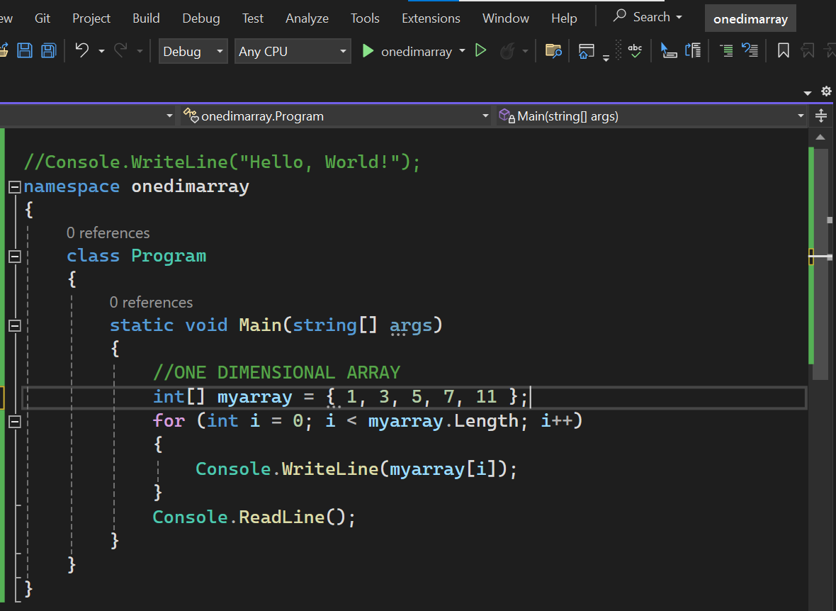
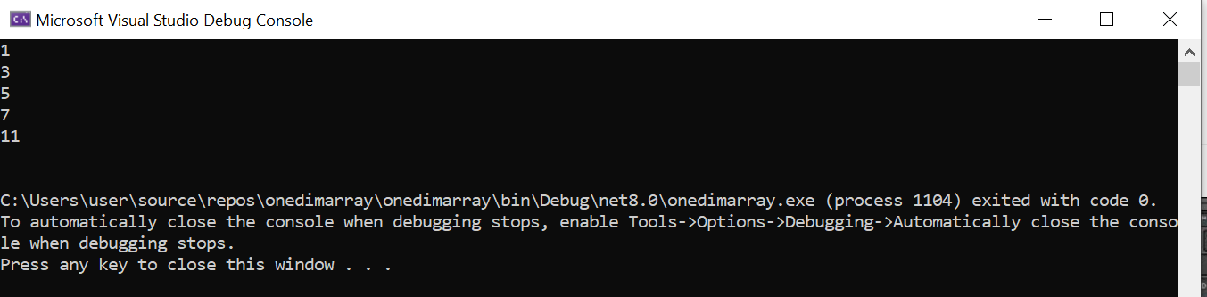

- MULTI-DIMENSIONAL ARRAY:

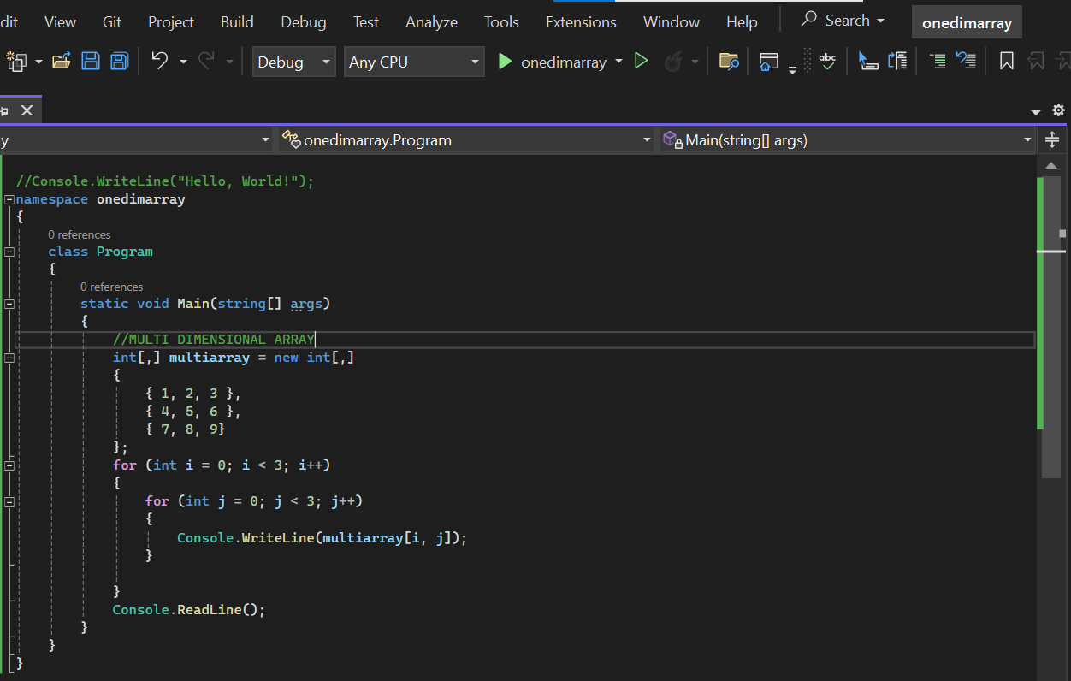
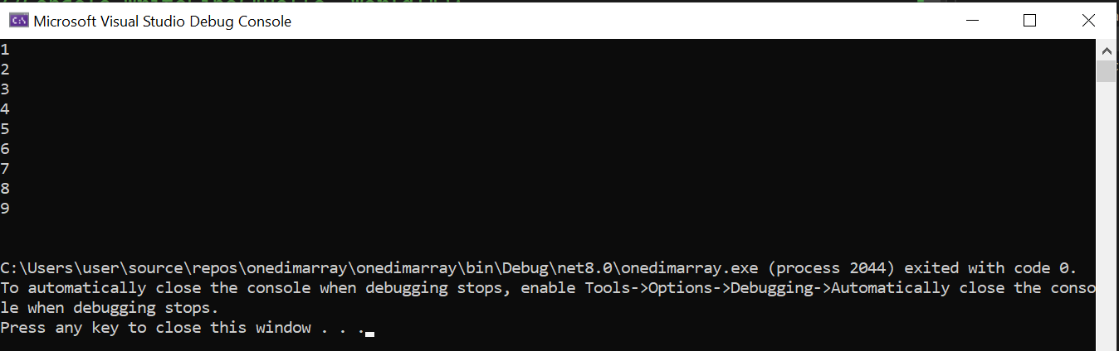

- JAGGED(NESTED) ARRAY:

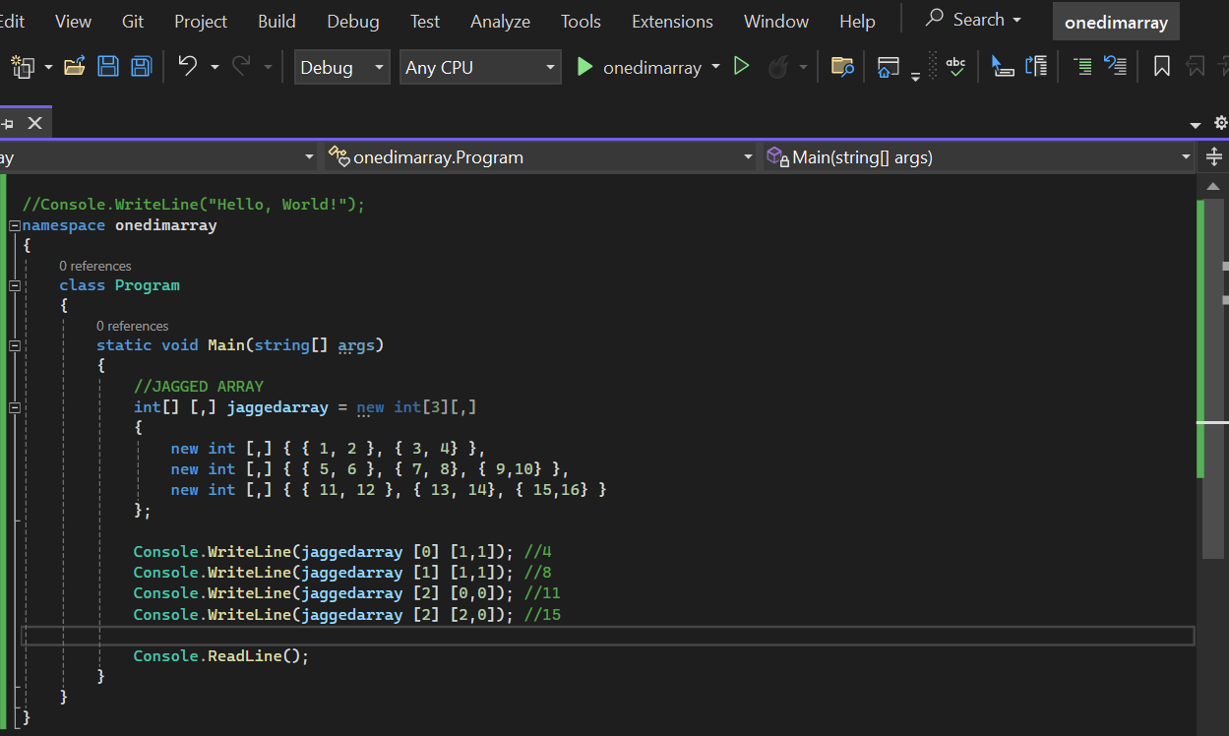
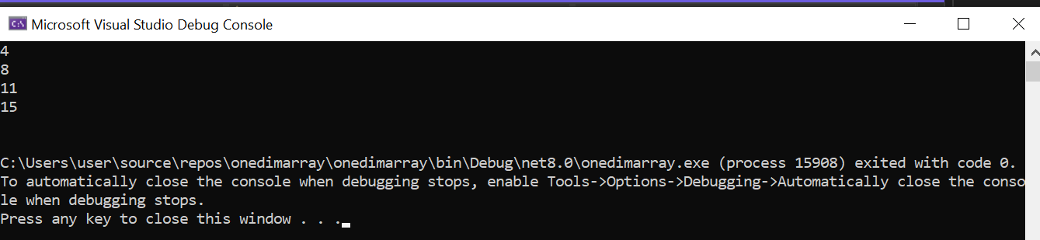

- Discussion:
Arrays and Array Lists are both used to store collections of elements in C#, but they have different characteristics and usage scenarios. Arrays have a fixed size, it can store homogeneous elements only, and elements in an array can be accessed directly using their index. Whereas in array list, it can dynamically resize themselves, allowing elements to be added or removed without specifying the size beforehand, it can store heterogeneous elements only; accessing elements in an Array List might be slower compared to arrays because of their dynamic resizing and boxing/unboxing operations for value types.

- Conclusion:
"In this lab, we learned that arrays have a fixed size and faster access, while ArrayLists offer flexibility with dynamic resizing. Knowing when to use each helps tailor data structures for specific programming tasks."

